Custom 16-bit RISC SoC for Digital Lock with VGA Status Display

Justin Natividad
College of Engineering
California State University, Long Beach
Long Beach
line 5: email address or ORCID
Gabriel Dao
College of Engineering
California State University, Long Beach
Long Beach
line 5: email address or ORCID
Mikko Taitague
College of Engineering
California State University, Long Beach
Long Beach
line 5: email address or ORCID

Abstract— This project proposes the design and implementation of a custom 16-bit RISC system on chip on the Nexys A7 100-T Board. The system will include a simple processor core, instruction ROM, data RAM and memory-mapped peripherals for switches, push buttons, LEDs, seven segment displays, and VGA output. The processor will execute a digital lock application in which a user enters a code through board inputs, and the system responds by displaying lock status messages such as locked, access granted, access denied, and lockout. The purpose of this project is to demonstrate processor design, memory interfacing, peripheral control, and hardware/software interaction in a visible and interactive embedded environment. The completed design will be verified through simulation of individual modules and demonstrated on the Nexys A7 board with real time visual output.

Introduction
This project implements a custom 16-bit RISC processor on the Nexys A7-100T FPGA board to control a digital lock system with VGA status output. The system demonstrates processor design, memory-mapped input/output, embedded control, and hardware verification. The processor executes a program stored in ROM to read user inputs, compare passcodes, update lock state, and drive peripheral outputs including LEDs, seven segment display, and VGA.

Background & Preliminaries

This project is centered on the design of a custom 16-bit RISC System-on-chip (SoC) implemented on the Nexys A7-100T FPGA board for a digital lock application with VGA status output. The overall system combines a simple processor core, instruction ROM, data RAM, and memory-mapped peripherals so that the lock behavior can be controlled in software while still being demonstrated through real hardware. In this design, the user enters a code through the board inputs, and the system responds by updating LEDs, seven-segment displays, and a VGA monitor with status messages such as LOCKED, ACCESED GRANTED, ACCESS DENIED and LOCKOUT. This makes the project a practical example embedded digital system design, since it integrates processor architecture, peripheral interfacing, and visble user feedback into one FPGA-based platform

Implementation

Top-Level Implementation of 16-bit RISC SoC
The Current implementation of the project was developed as an early functional prototype of the cutom 16-bit RISC SoC. At this stage, the design is organized as a single top-level circuit that combines the processor datapath, instruction memory, data memory, control selection logic, and memory-mapped peripheral registers. This prototype is being used to verify the system architecture before full FPGA/Vivado integration. This aligns with the project goal of building a simple processor core with ROM, RAM, and memory-mapped peripherals for user interaction and output control.

Program Counter + Instruction ROM
The processor portion of the circuit includes a 16-bit program counter, an instruction ROM, and a collection of general-purpose 16-bit registers labeled through R0 through R7.
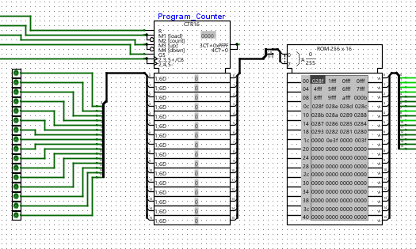
The arithmetic and logic functionality is implemented using dedicated 16-bit adder, subtractor, and compartor, AND, OR, and NOT logic blocks. These components provide the core operations needed for the lock-control application, such as comparing entered values, updating state, and generating control-dependent results. Together, these blocks serve as the working ALU portion of the processor prototype
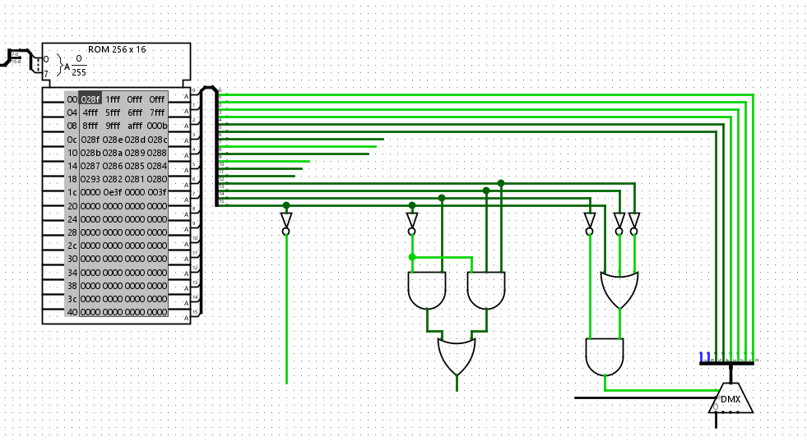

Register file area
For memory support, the circuit contains both instruction ROM and data RAM. The instruction ROM stores the current machine-level program as hexadecimal values, while the RAM is reserved for temporary values and internal state storage. In addition, the design includes several memory-mapped peripheral registers, including BT-Reg for button input, SW_Reg for switch input, LED_Reg for LED output, RGB_Reg for RGB LED output, and Seg7 through Seg0 for seven-segment display output. This follows the intended memory-mapped I/O approach, where the CPU communicates with peripherals through register addresses instead of separate dedicated control paths.
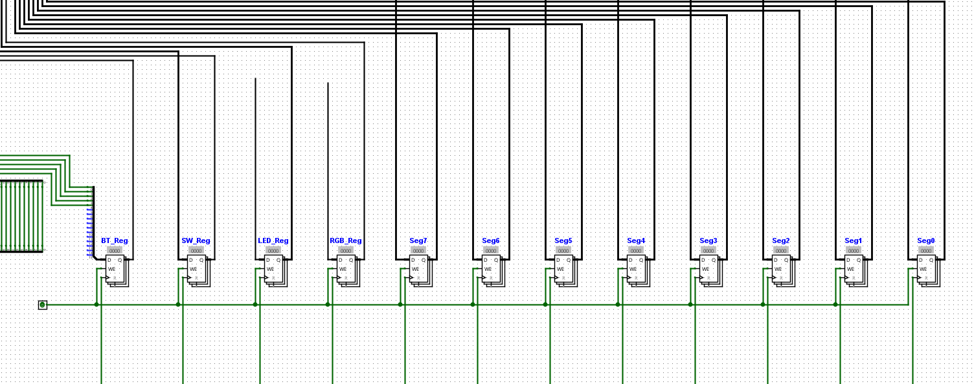

VGA (Coming soon)

Using the Template
After the text edit has been completed, the paper is ready for the template. Duplicate the template file by using the Save As command, and use the naming convention prescribed by your conference for the name of your paper. In this newly created file, highlight all of the contents and import your prepared text file. You are now ready to style your paper; use the scroll down window on the left of the MS Word Formatting toolbar.

Authors and Affiliations
The template is designed for, but not limited to, six authors. A minimum of one author is required for all conference articles. Author names should be listed starting from left to right and then moving down to the next line. This is the author sequence that will be used in future citations and by indexing services. Names should not be listed in columns nor group by affiliation. Please keep your affiliations as succinct as possible (for example, do not differentiate among departments of the same organization).

For papers with more than six authors: Add author names horizontally, moving to a third row if needed for more than 8 authors.

For papers with less than six authors: To change the default, adjust the template as follows.

Selection: Highlight all author and affiliation lines.

Change number of columns: Select the Columns icon from the MS Word Standard toolbar and then select the correct number of columns from the selection palette.

Deletion: Delete the author and affiliation lines for the extra authors.

Identify the Headings
Headings, or heads, are organizational devices that guide the reader through your paper. There are two types: component heads and text heads.
Component heads identify the different components of your paper and are not topically subordinate to each other. Examples include Acknowledgments and References and, for these, the correct style to use is “Heading 5”. Use “figure caption” for your Figure captions, and “table head” for your table title. Run-in heads, such as “Abstract”, will require you to apply a style (in this case, italic) in addition to the style provided by the drop down menu to differentiate the head from the text.
Text heads organize the topics on a relational, hierarchical basis. For example, the paper title is the primary text head because all subsequent material relates and elaborates on this one topic. If there are two or more sub-topics, the next level head (uppercase Roman numerals) should be used and, conversely, if there are not at least two sub-topics, then no subheads should be introduced. Styles named “Heading 1”, “Heading 2”, “Heading 3”, and “Heading 4” are prescribed.

Figures and Tables

Positioning Figures and Tables: Place figures and tables at the top and bottom of columns. Avoid placing them in the middle of columns. Large figures and tables may span across both columns. Figure captions should be below the figures; table heads should appear above the tables. Insert figures and tables after they are cited in the text. Use the abbreviation “Fig. 1”, even at the beginning of a sentence.

- Table Type Styles
Table Head | Table Column Head
Table Head | Table column subhead | Subhead | Subhead
copy | More table copyª
- Sample of a Table footnote. (Table footnote)
- Example of a figure caption. (figure caption)
Figure Labels: Use 8 point Times New Roman for Figure labels. Use words rather than symbols or abbreviations when writing Figure axis labels to avoid confusing the reader. As an example, write the quantity “Magnetization”, or “Magnetization, M”, not just “M”. If including units in the label, present them within parentheses. Do not label axes only with units. In the example, write “Magnetization (A/m)” or “Magnetization {A[m(1)]}”, not just “A/m”. Do not label axes with a ratio of quantities and units. For example, write “Temperature (K)”, not “Temperature/K”.

Acknowledgment (Heading 5)
The preferred spelling of the word “acknowledgment” in America is without an “e” after the “g”. Avoid the stilted expression “one of us (R. B. G.) thanks ...”. Instead, try “R. B. G. thanks...”. Put sponsor acknowledgments in the unnumbered footnote on the first page.

References
The template will number citations consecutively within brackets [1]. The sentence punctuation follows the bracket [2]. Refer simply to the reference number, as in [3]—do not use “Ref. [3]” or “reference [3]” except at the beginning of a sentence: “Reference [3] was the first ...”
Number footnotes separately in superscripts. Place the actual footnote at the bottom of the column in which it was cited. Do not put footnotes in the abstract or reference list. Use letters for table footnotes.
Unless there are six authors or more give all authors’ names; do not use “et al.”. Papers that have not been published, even if they have been submitted for publication, should be cited as “unpublished” [4]. Papers that have been accepted for publication should be cited as “in press” [5]. Capitalize only the first word in a paper title, except for proper nouns and element symbols.
For papers published in translation journals, please give the English citation first, followed by the original foreign-language citation [6].

- G. Eason, B. Noble, and I. N. Sneddon, “On certain integrals of Lipschitz-Hankel type involving products of Bessel functions,” Phil. Trans. Roy. Soc. London, vol. A247, pp. 529–551, April 1955. (references)
- J. Clerk Maxwell, A Treatise on Electricity and Magnetism, 3rd ed., vol. 2. Oxford: Clarendon, 1892, pp.68–73.
- I. S. Jacobs and C. P. Bean, “Fine particles, thin films and exchange anisotropy,” in Magnetism, vol. III, G. T. Rado and H. Suhl, Eds. New York: Academic, 1963, pp. 271–350.
- K. Elissa, “Title of paper if known,” unpublished.
- R. Nicole, “Title of paper with only first word capitalized,” J. Name Stand. Abbrev., in press.
- Y. Yorozu, M. Hirano, K. Oka, and Y. Tagawa, “Electron spectroscopy studies on magneto-optical media and plastic substrate interface,” IEEE Transl. J. Magn. Japan, vol. 2, pp. 740–741, August 1987 [Digests 9th Annual Conf. Magnetics Japan, p. 301, 1982].
- M. Young, The Technical Writer’s Handbook. Mill Valley, CA: University Science, 1989.

We suggest that you use a text box to insert a graphic (which is ideally a 300 dpi TIFF or EPS file, with all fonts embedded) because, in an MSW document, this method is somewhat more stable than directly inserting a picture.
To have non-visible rules on your frame, use the MSWord “Format” pull-down menu, select Text Box > Colors and Lines to choose No Fill and No Line.

